**Print Settings Guide**

This guide will cover the basic functions of the Print window. This will include:

1. **Destination**
2. **Copies**
3. **Orientation**
4. **Pages**
5. **Color Mode**
6. **Paper Size**
7. **Scale**
8. **Pages per Sheet**
9. **Margins**
10. **Two-Sided Printing**
11. **Destination**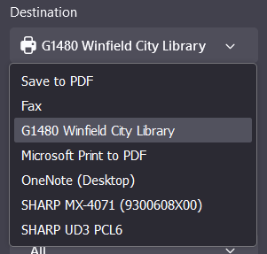

The destination refers to where the document will print. This setting usually appears as a “drop down menu,” where multiple options will appear based on what printers are set up to communicate with your device.

You might notice a few options that are not printers, such as “Save to PDF” or “Print to PDF.” This action allows you to save the document to your computer in a format that will be easy to find or print another time.

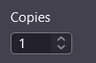

1. **Copies**

This is the number of times you want your printer to print off your entire document. For example, if you want two versions of the document, you would type “2” into the box. You can also use the up or down arrows to increase or decrease the amount one at a time.

1. **Orientation**

This refers to the direction of the paper. “Portrait” means that the document will print in such a way that the top of the paper is a shorter length than the sides, where “Landscape” means that the paper will be turned sideways, so that the long side is on top.

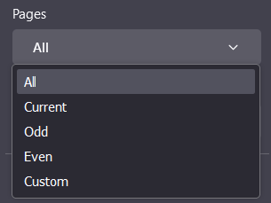

1. **Pages**

This is the setting that allows you to choose which parts of a document to print. You can print the whole document, the current page, pages with even or odd numbers, or a custom selection. Any pages that are not included in the selection will not be printed off.

To choose a custom selection, you can provide a range of page numbers to print. For example, if your document is 20 pages, but you only want to print off the first half, you can select “custom” and type “1-10” to print off the first ten pages of the document.

1. **Color Mode**

This is how you tell the printer whether you want your document in black and white or in color.

*Note:* A document that only contains black text will print off as black text even if you select the option for color.

1. **Paper Size**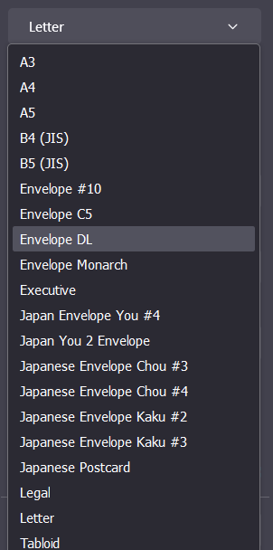

This setting tells the printer what size paper to use. Most documents will be printed on Letter sized paper, or 8.5”x11”. Some printers allow you to print on other kinds of paper, as well. You should only need to change this setting if you plan on using a non-standard paper size. Different paper sizes are given standardized names that refer to their dimensions or use.

1. **Scale**

You can use this setting to “zoom in” or “zoom out” on your document. Increasing the percentage in this box will cause your document to print out larger, and decreasing the percentage will make it print smaller. You should be careful with this setting, as increasing the size might cause your printer to not print the edges of your document, or to split your document into extra pages. You can use the setting “Fit to page width” to ensure that your document will fit the size of paper that is selected.

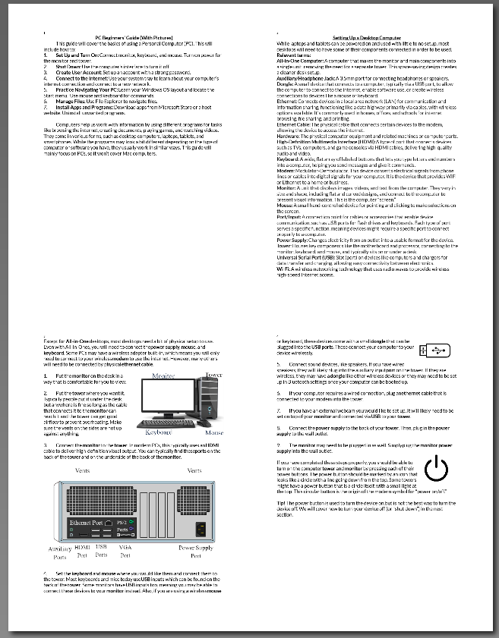

1. **Pages per Sheet**

This setting allows you to tell your printer to print multiple pages of your document on the same side of one sheet of paper. This means that the document will shrink down to fit more information in the same space. This is not the setting to change if you want to print on both sides of the sheet of paper.

1. **Margins**

“Margins” are the space at the very edge of your paper, around the border of the design. Most printers leave a small amount of white space at the edges of the document. You can change this setting to adjust the amount of white space or even remove it entirely.

1. **Two-sided Printing**

This is how you tell the printer whether you want it to use both the front and back of your paper. You are given the option to “flip on the long edge” or “flip on the short edge.” On a Portrait-style document, flipping on the “long edge” will mean that your document will face the same direction on both sides of the paper, while flipping on the “short edge” would print the back upside-down. If your document is printing in Landscape mode, the opposite would be true. Flipping on the “long edge” would make the back of the paper print upside-down.

