**How to Change Language Settings**

**and Use the Translate Feature in Google Chrome**

This guide will cover how to change the language settings and use the Translate feature in Google Chrome. These features are similar in that they change the language presented in the browser, but cover two different areas.

**Language Settings:** Changes the language used in the browser itself. Google has manually entered the different controls, so this will reliably be understandable and free of errors or typos.

**Translate Feature:** A built-in feature to Chrome that uses an algorithm to change the content of a webpage to be automatically translated into another language. Because words can have multiple context-dependent meanings, there may be some errors in the translation.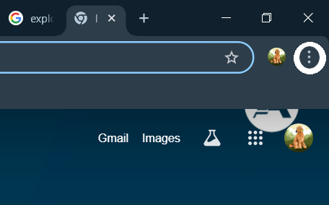

**Changing Language Settings**

1. When you have the Google Chrome browser open, look to the top right part of your screen. Just under the exit “X”, you will see three dots. Click the three dots to open your options menu. 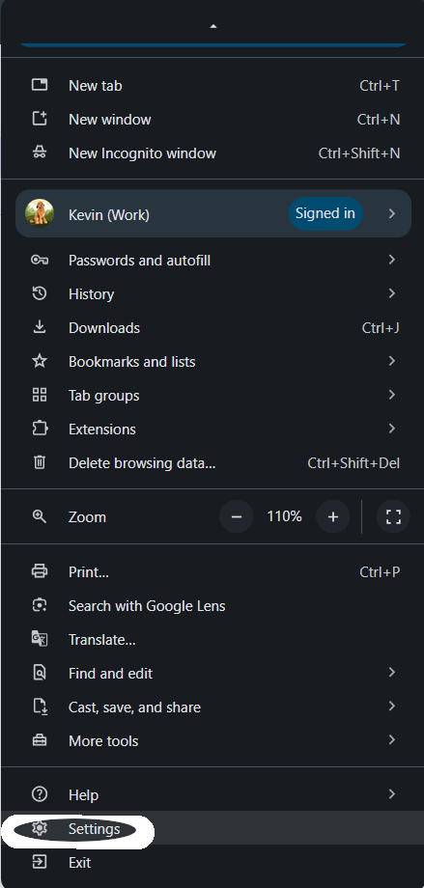
2. From the drop down menu, click on “Settings”. It should be near the bottom and will have an image of a gear next to it. You may need to hover over the menu and scroll down to find Settings. 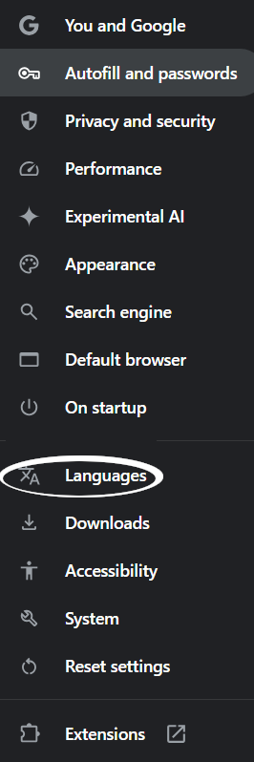
3. Choose the Language settings from the list. It will be about two-thirds of the way down the list and have an image next to it with the letter “A” next to a katakana (Japanese) character.
4. Look under Preferred Languages. If your language is in the list, click the 3 dots next to it and check “Display Chrome in this Language”. If the language you need isn’t there, click “Add Languages”. You can search for languages in the search bar. It will have regional dialects for some languages as well. Select your language. This will add it to the Preferred Languages page, so simply click the 3 dots next to it and check “Display Chrome in this Language”.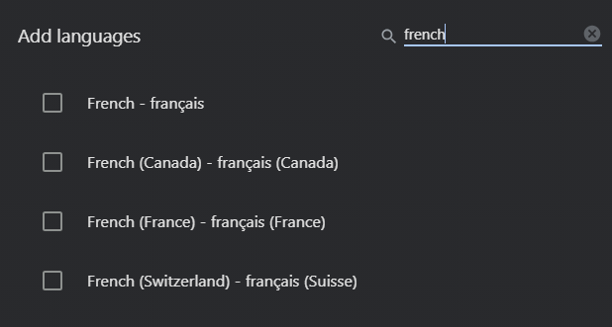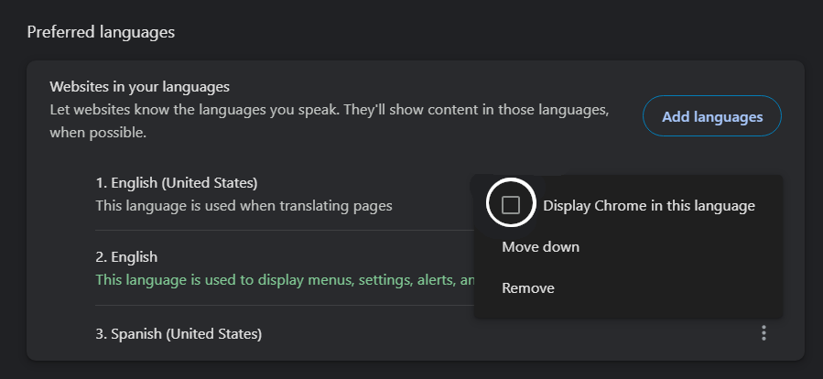

**Using the Translate Feature on Google Chrome**



1. When you have the Google Chrome browser open, look to the top right part of your screen. Just under the exit “X”, you will see three dots. Click the three dots to open your options menu.
2. Click on “Translate” from the drop down menu. It will be about two-thirds of the way down the list and have an icon with 2 documents: one with the Google G and one with a katakana (Japanese character). 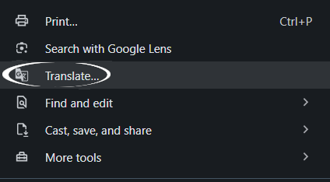
3. If the language you want to translate to is the same as the language your browser is set to, it will appear at the top. Click it and it will translate the page. 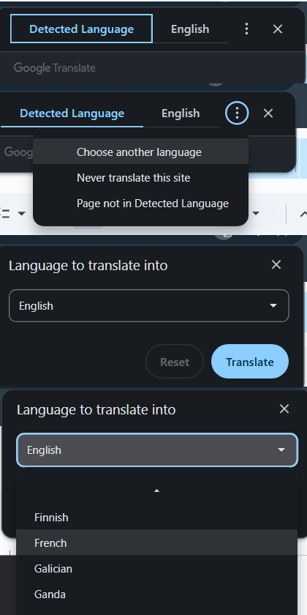
4. If the language you want to translate is not displayed at the top, click the three dots and select “Choose another language” from the drop down menu.
5. Click the arrow on the right of the box. Scroll through the options until you find the language you want to translate to. Click that language. The page should now be automatically translated to your preferred language. 

**Warning: While the Translate tool can be very helpful, it can also get things wrong and mistranslate context specific words and phrases. Keep this in mind while using this feature.**