**PC Beginners’ Guide (With Pictures)**

This guide will cover the basics of using a Personal Computer (PC). This will include how to:

1. **Set Up and Turn On:** Connect monitor, keyboard, and mouse. Turn on power for the monitor and tower.
2. **Shut Down:** Use the computer’s interface to turn it off.
3. **Create User Account:** Set up an account with a strong password.
4. **Connect to the Internet:** Use your system tray to learn about your computer’s internet connection and connect to a new network.
5. **Practice Navigating Your PC:** Learn your Windows OS layout and locate the Start menu. Use mouse and keyboard for commands.
6. **Manage Files:** Use File Explorer to navigate files.
7. **Install Apps and Programs:** Download apps from Microsoft Store or a host website. Uninstall unwanted programs.

Computers help us work with information by using different programs for tasks like browsing the internet, creating documents, playing games, and watching videos. They come in various forms, such as desktop computers, laptops, tablets, and smartphones. While the programs may look a bit different depending on the type of computer or software you have, they usually work in similar ways. This guide will mainly focus on PCs, so it won’t cover Mac computers.

**Setting Up a Desktop Computer**

While laptops and tablets can be powered on and used with little to no setup, most desktops will need to have some of their components connected in order to be used.

**Relevant terms:**

**All-in-One Computer:** A computer that makes the monitor and main components into a single unit, removing the need for a separate tower. This space-saving design creates a cleaner desk setup.

**Auxiliary/Headphone Jack:** A 3.5mm port for connecting headphones or speakers.

**Dongle:** A small device that connects to a computer, typically via a USB port, to allow the computer to connect to the internet, enable software use, or create wireless connections to devices like a mouse or keyboard.

**Ethernet:** Connects devices in a local area network (LAN) for communication and information sharing, functioning like a data highway primarily via cables, with wireless options available. It's commonly used in homes, offices, and schools for internet browsing, file sharing, and printing.

**Ethernet Cable:** The physical cable that connects certain devices to the modem, allowing the device to access the internet.

**Hardware:** The physical computer equipment and related machines or computer parts.

**High-Definition Multimedia Interface (HDMI):** A type of port that connects devices such as TVs, computers, and game consoles via HDMI cables, delivering high-quality audio and video.

**Keyboard:** A wide, flat array of labeled buttons that lets you type letters and numbers into a computer, helping you send messages and give it commands.

**Modem:** Modulator-Demodulator. This device converts electrical signals from phone lines or cables into digital signals for your computer. It is the device that provides WiFi or Ethernet to a home or business.

**Monitor:** A unit that displays images, videos, and text from the computer. They vary in size and shape, including flat and curved designs, and connect to the computer to present visual information. This is the computer “screen.”

**Mouse:** A small hand-controlled device for pointing and clicking to make selections on the screen.

**Port/Input:** A connection point for cables or accessories that enable device communication, such as USB ports for flash drives and keyboards. Each type of port serves a specific function, meaning devices might require a specific port to connect properly to a computer.

**Power Supply:** Changes electricity from an outlet into a usable format for the device.

**Tower:** Houses key components like the motherboard and processor, connecting to the monitor, keyboard, and mouse, and typically sits on or under a desk.

**Universal Serial Port (USB):** Slot (port) on devices like computers and chargers for data transfer and charging, allowing easy connectivity between electronics.

**Wi-Fi:** A wireless networking technology that uses radio waves to provide wireless high-speed Internet access.

Except for **All-in-One** desktops, most desktops need a bit of physical setup to use. Even with All-in-Ones, you will need to connect the **power supply**, **mouse**, and **keyboard**. Some PCs may have a wireless adapter built-in, which means you will only need to connect to your wireless **modem** to use the internet. However, many others will need to be connected by physical **ethernet** **cable**.

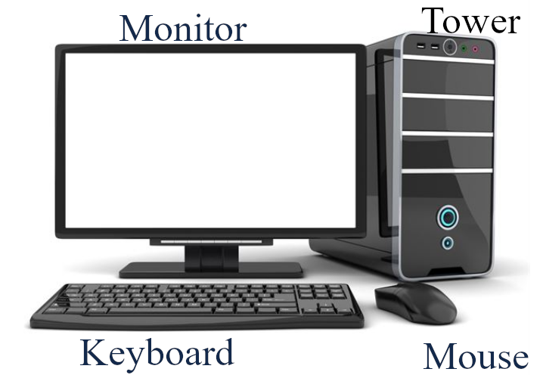

1. Put the **monitor** on the desk in a way that is comfortable for you to view.
2. Put the **tower** where you want it. Typically people put it under the desk, but anywhere is fine so long as the cable that connects it to the **monitor** can reach it and the tower can get good airflow to prevent overheating. Make sure the vents on the sides are not up against anything.
3. Connect the **monitor** to the **tower**. In modern PCs, this typically uses an **HDMI** cable to deliver high-definition visual output. You can typically find these **ports** on the back of the **tower** and on the underside of the back of the **monitor.**

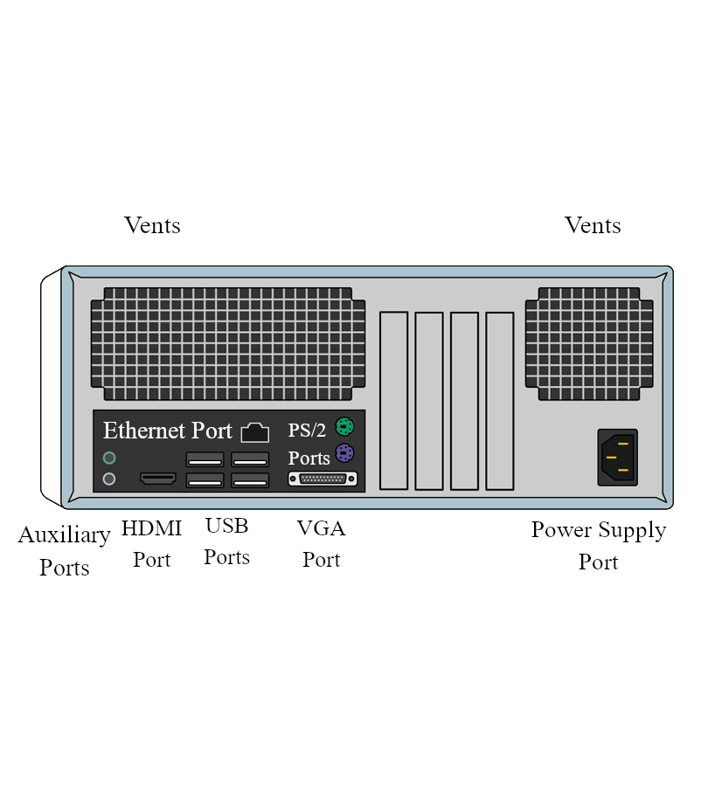

1. Set the **keyboard** and **mouse** where you would like them and connect them to the tower. Most keyboards and mice today use **USB** inputs which can be found on the back of the **tower**. Some monitors have **USB** inputs too, meaning you may be able to connect these devices to your **monitor** instead. Also, if you are using a wireless **mouse** or keyboard, these devices come with a small **dongle** that can be plugged into the **USB ports**. These connect your computer to your device wirelessly.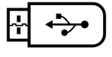
2. Connect sound devices, like speakers. If you have wired speakers, they will likely plug into the auxiliary input **port** on the tower. If they are wireless, they may have a **dongle** like other wireless devices or they may need to be set up in Bluetooth settings once your computer can be booted up.
3. If your computer requires a wired connection, plug an **ethernet cable** that is connected to your modem into the tower.

1. If you have an external webcam you would like to set up, it will likely need to be set on top of your **monitor** and connected via **USB** to your **tower**.

1. Connect the **power supply** to the back of your **tower**. Then, plug in the **power supply** to the wall outlet.
2. The **monitor** may need to be plugged in as well. Simply plug the **monitor** **power supply** into the wall outlet.

If you have completed these steps properly, you should be able to turn on the computer **tower** and **monitor** by pressing each of their power buttons. The power button should be marked by an icon that looks like a circle with a line going down from the top. Some towers might have a power button that is a circle itself, with a small light at the top. This circular button is the origin of the modern symbol for “power on/off.”

**Tip!** The power button is used to turn the device on, but is not the best way to turn the device off. We will cover how to turn your device off (or “shut down”) in the next section.

**Shutting Down a Desktop Computer**

Now we will discuss the best way to turn your computer off. You might think that the power button can be used to both turn the computer on and off, but this is not completely true. Using the power button to turn your computer off can cause issues with your files or with the device itself. Shutting down your computer can vary by its Operating System, or OS. In this section, we will show you how to shut down a computer that runs on Windows OS.

Powering off a computer is important for a few reasons. First, it helps to save energy, so you aren't wasting electricity. Second, shutting down properly allows the system to finish any tasks it's doing and helps prevent data loss or corruption. Third, it can help make the hardware last longer because always having it on can wear it out. Finally, a proper shutdown can sometimes fix issues or glitches, helping the computer run better when you turn it back on.

If you do not turn off a computer properly, a few things can go wrong. First, it might get stuck on a program or file, which can lead to data loss if you haven't saved your work. This can also cause the computer to run slowly or behave strangely the next time you use it.

Additionally, leaving it on for a long time can lead to overheating, which can damage the hardware. It can also drain power without reason, increasing your electricity bill. In some cases, if updates are waiting to install, not shutting it down might prevent those updates from happening, which can leave your system open to malware attacks from viruses. Therefore, it is generally a good idea to turn it off properly when you’re done using it.

**Relevant Terms:**

**Cursor:** The arrow on your screen that follows your mouse or trackpad.

**Desktop:** Can refer to a type of computer with separate parts (monitor, keyboard, tower, etc.) or the primary display area on the computer screen that appears once a user has logged in. Use context to determine if you are learning about a type of computer or the image displayed on the monitor.

**Icon:** A small graphical representation of a computer program or file.

**Left Click:** The act of pressing the button on the left side of the mouse to interact with something displayed on your computer screen. This is also simplified to “click.” If you are told to “click” on something, it will almost always mean to use the left mouse button, as clicks with the right mouse button will usually be specified as “right click”.

**Login and Log in/on:** "Login" refers to your username and password used to access your account, while "log in" or “log on” is the act of signing in with that login info. You can also “log off” to sign out of your account and lock it.

**Menu:** A list of choices that helps you find your way around a program. For example, a menu in an app might have options like File, Edit, and View. When you click on these, they show more options related to those categories, like saving your documents or changing settings.

**Keyboard Shortcuts:** The act of pressing multiple keyboard keys at the same time to tell the computer to do something. Keyboard shortcuts aid users, especially those with mobility impairments, in using a computer without a mouse.

**PC:** While this acronym originally stood for Personal Computer, it now usually refers specifically to a device that runs on Windows Operating System.

**Operating System (OS):** An operating system is important software that helps a computer work and run programs. The three most common ones are Microsoft Windows, Apple Mac OS, and Linux.

**Screen:** A flat display on a monitor that shows pictures, videos, and text. It acts as a digital window for using software and browsing the internet. Screens come in different sizes and are usually made of glass or plastic. The monitor is the whole device, but the screen is just the part that displays images.

**Start Menu:** A Windows feature for quick access to programs, settings, and files, typically opened by clicking a button in the corner of the screen. This button usually appears as the Windows logo, which may look slightly different depending on the version of Windows your computer is using.

**Taskbar:** A stationary strip of icons used to access frequently-used programs like Internet browsers and Microsoft products, usually found at the bottom of the screen. This feature also displays what programs are currently running on the device.

To turn off a PC, choose one of these methods:

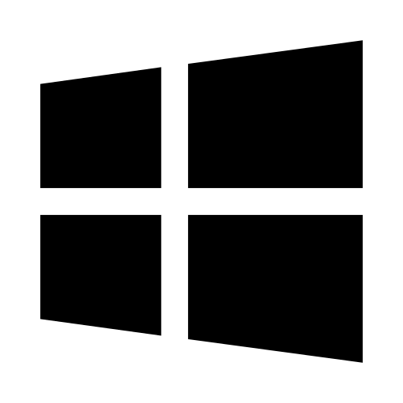

**Start Menu:**

1. Locate the taskbar. By default, this bar appears across the bottom of your screen. Depending on the version of Windows you are using, the Windows **icon** will appear at either the bottom left corner or the middle left of the taskbar. This is your “Start” button.
2. Using your mouse, move the **cursor** to this **icon** and use the left button to “click” it. This will open the **Start Menu**. At the bottom of this **menu**, you may see the words “Shut Down,” “Power off,” or this function may be indicated by the Power **icon**.
3. **Left click** on the “Shut Down” button to tell the computer to perform that function and turn itself off. If Microsoft has released new updates, the **menu** will give you the option to “Update and Shut Down,” perhaps even replacing the “Shut Down” button entirely. Keeping your **PC** up to date is important for keeping it safe from malware such as viruses. If updates need to take place, your computer may take some time to download them before it completely powers off. You should not use the physical power button during these updates, or it may cause damage to your computer.

**Keyboard Shortcut:**

To close the program you're using, press Alt + F4. If you're on your **desktop**, pressing Alt + F4 will bring up a menu. From there, choose “Shut down” and hit "OK" to turn off your computer. You can also switch users from this menu.

**Ctrl + Alt + Del:** This keyboard shortcut can be used to shut your computer down. Press the keys that say Ctrl, Alt, and Delete at the same time. Your screen will turn a solid color with a few different options listed in the middle, such as “Lock,” “Switch User,” and “Sign Out” or “Log Off.” Locate the familiar power **icon** located in the bottom right corner of your screen. **Left click** on this **icon**, and then select “Shut down.

If your computer is not responding and feels slow or stuck, you might need to press the power button to turn it off.

**Physical Power Button:**

1. Press and hold the power button until the tower shuts down; be cautious, as frequent use may risk data loss or damage.

**Creating an Account or User Profile**

For most PCs, you will need to create a **user account**. While you can have everyone in the household use the same user account, it is often better to have a separate account for each user. Separate user accounts are crucial for privacy, organization, and security. They stop users from making unintentional changes to someone else's files and settings, allowing users to customize their experience on their own.

To set up a user account on a computer, go to Settings or Control panel, find User Accounts, and create a new account with a **Username** and **Password**. This allows for personal file storage and customization without affecting others.

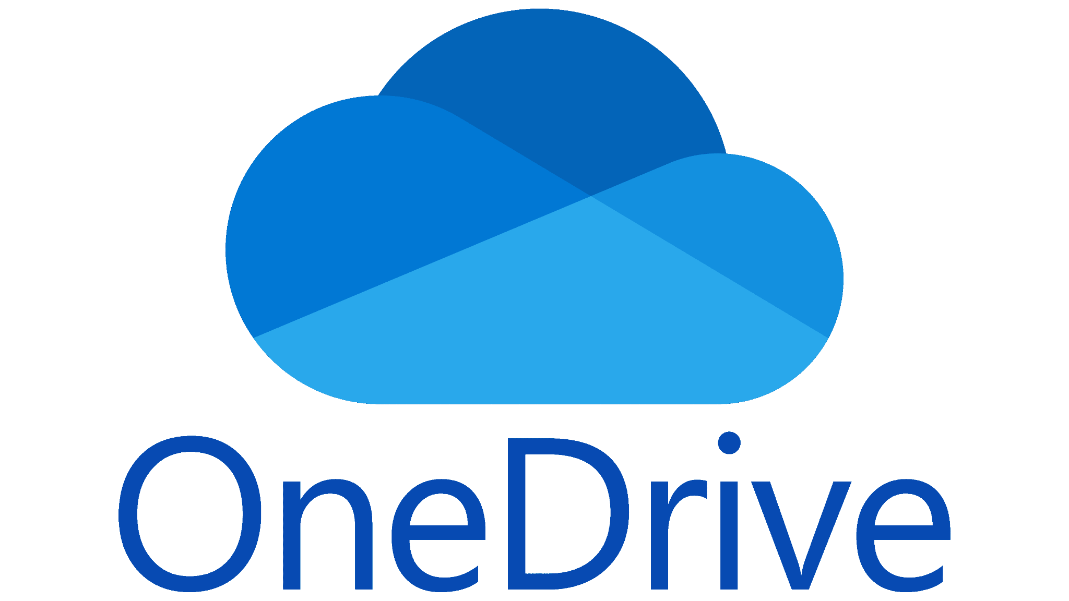

For Windows computers, users have the option to tie their account to a Microsoft account. This can allow access to **OneDrive**, a **cloud** storage service that can make switching PCs easier by keeping important documents, photos, videos, and other files safe on the **cloud** and accessible to multiple computers.

**Relevant Terms:**

**Account:** A computer account provides a personal space for file storage, settings customization, and program installation, allowing you to manage your documents without disrupting other users.

**Cloud:** “The Cloud" is a service to use the internet to allow us to access information from anywhere. Cloud services include things like OneDrive and Google Drive that allow for access to files anywhere that a person has an internet connection.

**Electronic mail (e-mail):** An email is a message sent from one computer or phone to another. It also refers to the account used to send emails. The format for email addresses is typically something like name@business.com.

**File:** A file is a stored piece of information on a computer, containing various digital content such as documents, images, music, or videos.

**Google Drive:** Google Drive is an online storage service for files, accessible from any internet-connected device. It enables file sharing for working together and is designed to be used with Google Docs and Sheets for online document creation and editing.

**iCloud:** Apple’s cloud service which allows Apple devices to communicate and share files. This includes iPads, iPhones, and Mac computers.

**OneDrive:** Microsoft’s cloud service which allows files to be shared between multiple internet-enabled devices through the use of a Microsoft account.

**Password:** A secret string of characters that must be used to gain access to an online service or to change or prevent access to software, such as parental controls.

**Search bar:** A rectangular or capsule-shaped icon, sometimes indicated by a magnifying glass, that you can type inside to find a desired program or page.

**Username:** The name a user selects to be identified on a computer, on a network, or in an online gaming service.

To set up a user **account** on a computer, follow these steps for a PC:

**For PC (Windows):**

1. *Turn on the Computer* - Start your PC and wait for the Windows **desktop** to load. This may include waiting for your computer to install updates or entering some key information, such as what country and time zone you are in and what language you would like the computer to use.



2. *Open Settings* - Click on the **Start menu** (Windows icon) at the bottom left corner or bottom center. Select the icon that looks like a gear to open Settings. Remember this icon, as most programs use the gear to indicate a settings **menu**. If you are having trouble locating the gear, you can also type the word “settings” into the **search bar**, which will cause settings to appear at the top of the results.

3. *Go to Accounts* - In the Settings window, click on “**Accounts**.”

4. *Select Family & other users* - On the left side, find and click on "Family & other users."

5. *Add a User* - Under the "Other users" section, click on "Add someone else to this PC."

6. *Choose Account Type* - You will be asked if the new user has a Microsoft **account**. If they do, enter the **email** address. If not, click on “I don’t have this person’s sign-in information” and then select “Add a user without a Microsoft **account**.”

7. *Create Username and Password* - Enter a **username** for the new account. You can also set a **password** (this is optional, but it's safer). Fill in any **password** hints if you want. These might help you remember what **password** you chose in case you forget it later on. The **username** and **password** together may also be referred to as your **“login.”**

8. *Finish Setup* - Click "Next" to finish creating the **account**. The new user will now be listed under "Other users."

9. *Sign In* - To switch users, click on the **Start menu**, select the user icon at the bottom, and choose the new **account** to log into.

**Connecting to the Internet:**

One of the most important functions of your computer is its ability to connect to the Internet. This can be done through a wired connection (ethernet) or wirelessly (WiFi.) This lesson will walk you through the differences between ethernet and WiFi, as well as how to check your device’s connection status and connect to a new network.

**Relevant Terms:**

**Airplane Mode:** A setting on many devices that disables mobile data and other communication features to avoid causing problems with the airplane's navigation equipment. When you enable this mode, you can't connect to any mobile internet, and won’t be able to use your phone as a hotspot.

**Ethernet:** An internet connection between devices in a local area network (LAN) for communication and information sharing, functioning like a data highway primarily via cables, with wireless options available. It's commonly used in homes, offices, and schools for internet browsing, file sharing, and printing.

**Ethernet Cable:** The physical cable that connects certain devices to the modem, allowing the device to access the internet.

**Hotspot:** A hotspot is a place where you can connect to Wi-Fi outside your house or office, like in libraries, cafes, airports, and stores. Mobile phone companies also offer devices or plans that let your phone act as a hotspot.

**LAN:** Local Area Network. This is a group of devices that are connected by a communications link and are usually located in a limited area. Devices on a LAN can communicate with each other securely and exchange data, like a computer connecting to a printer.

**Mobile Data:** Internet content delivered to mobile devices such assmartphones and tablets over a wireless cellular connection.

**Mobile Hotspot**: A hotspot is a place where you can connect to Wi-Fi outside your house or office, like in libraries, cafes, airports, and stores. Mobile phone companies also offer devices or plans that let your phone act as a hotspot and share its connection with other devices.

**Open Network:** A WiFi network that does not require a password to access, making it easier to access but more vulnerable to attacks.

**Secure Network:** A WiFi network that requires a password to access, keeping connected devices more safe from attacks.

**System Tray:** A stationary taskbar that contains icons for system functions like time, date, and audio volume.  
**WiFi or Wi-Fi:** A set of rules that lets devices share information wirelessly through the internet. Devices that are WiFi enabled can work together without any issues.

To connect to the internet on a PC, follow these steps.

1. Locate your **system tray.** This is the group of icons at the bottom right of your screen, including the time and date.
2. Identify your Internet Connections menu. This menu can be represented by a few different symbols, depending on your current connection status. 
   1. *Not Connected:* A symbol that looks like a globe with a little “no” symbol (a circle crossed through with a diagonal line) symbol to one corner indicates that your computer is not currently connected to the internet.
   2. *Wired Connection/****Ethernet****:* This type of connection is represented by an icon that might look like the wire itself, or like a monitor and a wire together.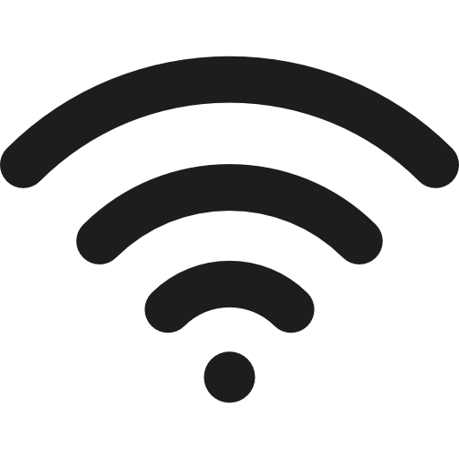
   3. *Wireless Connection/****WiFi****:* This type of connection is represented by a dot with curved lines radiating upward, or sometimes to the side.
3. Clicking on this symbol will open a new menu of connection options. In some versions of Windows, you might be required to click on another arrow or “**caret**” to expand the menu further.

Your next steps might look a little different depending on your device and what type of connection you are hoping to make. 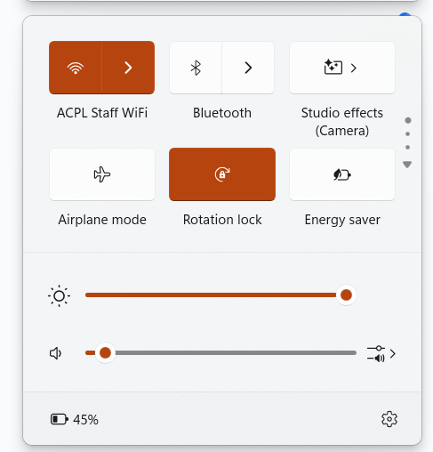

**Connecting to WiFi:**

1. Make sure that your device has **WiFi** turned on. You should see a list of the available networks in your area.
2. Locate the network you’d like to use. Each network should have its own name, and the **WiFi** symbol beside it might look a little different. The lines coming out from the middle can be either light or dark. Dark lines show a stronger connection, while light lines suggest a weaker connection. This can be due to physical distance from the modem that is providing the **WiFi**. Some icons might also have a symbol that looks like a lock. This indicates a **secure network** that will require a password to access.
3. Enter the network password, if necessary. Even public networks will sometimes require a password. If you are trying to connect to your own modem and have not yet set up a personalized password, the default password will likely be written on the bottom of the modem itself.

Connecting via **Ethernet**: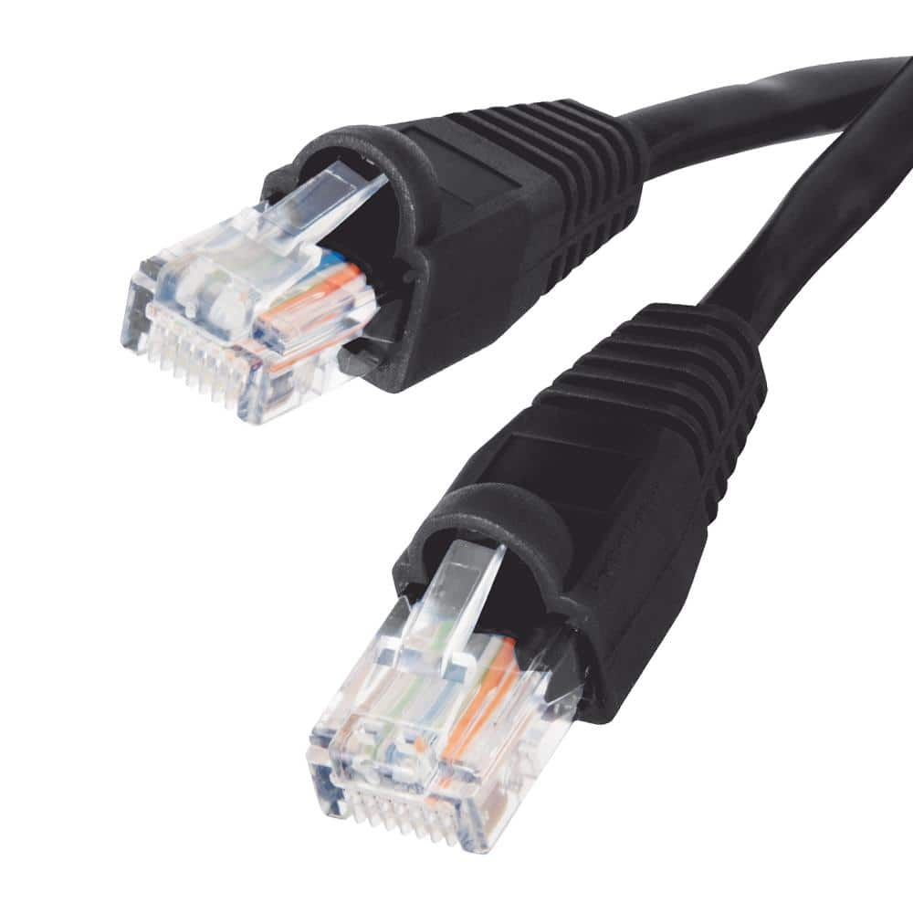

1. Locate your Ethernet cable. It might look similar to a phone cable, with a clear plastic tip on either end.
2. Locate your computer’s Ethernet ports. If you are using a desktop computer, this port will be on the back of your tower. If you are using a laptop, it will likely appear on the base of the computer. The port will match the shape of the cable. It should look like a rectangle with a sort of stair-step shape on one side.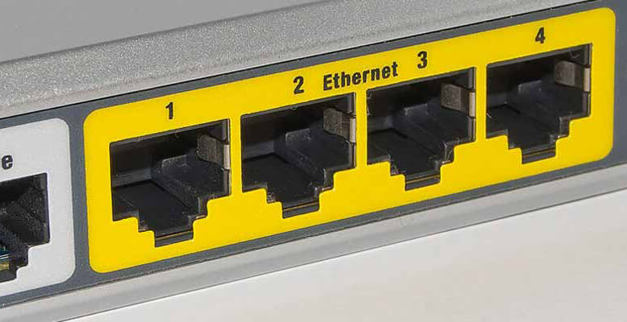
3. Locate the Ethernet ports on your modem. They should look the same as the ports on your computer.
4. Insert the cable ends into the ports. Many Ethernet cables have a tab on one side that needs to be pressed down to insert the cable, and then released to hold it in place. If you need to remove the cable, you should hold the tab down to release the pressure as you remove it. This will avoid damaging the cable.
5. If necessary, enter the network password. If you have not yet set up a personalized password, the default one will likely be written on the bottom of the modem itself. Be careful when you lift the modem. If you accidentally jerk the cable, it can cause issues with your connection.

After you have completed these steps, you should double check your connection. It may take your computer a moment to register its new internet access. Once it has successfully connected, you can look through your Internet Connection menu again and make sure that it says the word “connected.” The menu might also say your connection is either “**secured**” or “**unsecured**,” referring to whether or not you used a password to access the network. If a network is “**unsecured**,” it means that someone else using the same network might be able to see what you are doing on the internet. 

This is one of the dangers of using a public internet connection. You won’t want to use public WiFi to access sensitive information, like your online banking or health records. In most cases, you can identify an encrypted connection to a site by locating the characters “https://” at the beginning of the website’s web address (URL), or the padlock icon to its left. However, this is not a surefire method. Cybercriminals are always learning new methods to trick users into downloading malicious software. The FBI recommends using caution and your best judgment to determine if a site is trustworthy.

**Airplane Mode and Mobile Hotspots:**

**Airplane Mode** is a setting on many devices that disables **mobile data** and other communication features to avoid causing problems with the airplane's navigation equipment. When you enable this mode, you can't connect to any mobile internet, and won’t be able to use your phone as a **hotspot**.

Many devices can share their internet connection with other devices by turning into a **mobile hotspot**. This means that if your phone or tablet provides its own internet access (usually by communicating with phone towers), other devices can connect to it and use that internet. Devices with this capability will offer security options like setting a password to connect to your hotspot or customizing its name. You should keep in mind that mobile devices will sometimes only include a limited amount of “**mobile data,**” or digital information they are allowed to load, in a single payment period. Using multiple devices to access the same connection might use up that **mobile data** faster, and could result in charges from your provider for overuse.

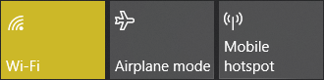

To turn on **Airplane Mode** or **Mobile Hotspot**, click the internet icon in the bottom right corner of your screen. There, you can click the **Airplane Mode** or **Mobile Hotspot** button to enable them.

If your device hasthe **Mobile Hotspot** feature and you have never set up its hotspot before, you may need to do the following:

1. Navigate to your **Mobile Hotspot** Settings page. You can do this by clicking the Internet Access icon in the bottom right of your screen. Then, click Network and Internet Settings and select the **Mobile Hotspot** settings. Also, you can use the **Search Bar** to search for **Mobile Hotspot** and reach the settings page there instead.
2. On the **Mobile Hotspot** Settings page, click Edit.
3. Here, you can change the name of the hotspot and the password. A password is important in ensuring strangers do not access your device.

**LAN (Local Area Network)**

Another aspect of internet connectivity is the ability of multiple devices on the same network to communicate with each other. The connection between these devices is referred to as **LAN**. Often, **LAN** can be used to allow devices to communicate with each other, like when a computer sends a document to a printer to allow it to print. Alternatively, **LAN** is also what causes a public, unsecured, or unknown **WiFi** connection to be somewhat dangerous. Other devices on a public network might be able to monitor your device and watch your online activity. This is why you shouldn’t use public **WiFi** to do sensitive or important tasks like online banking or entering your social security number.

**Navigating Your Computer**

Congratulations, you’ve finished setting up your computer! Now you are free to use it to complete any number of tasks, like using the internet to search for the latest news or check your email, using text documents to write up a letter, or storing all your photos to your local drive. But how does any of that work? Well, it depends on what Operating System your computer is running. In almost all cases, your computer will already be using either a Windows or Mac Operating System. In this segment, we will introduce you to some of the basic functions of the Windows Operating System and how to use them to make your computer do the work you’d like it to do.

**Relevant terms:**

**Caret:** refers to the symbol “^” which can have several different meanings, including standing in for an upward-pointing arrow or indicating an exponent.

**Icon:** An icon is a small picture on your screen that stands for an action or a file.

**Key:** a button on a keyboard that tells the computer to do a specific task, such as typing a symbol or highlighting the next option in a list.

**Menu:** A computer menu is a list of choices that help you find your way around a program. For example, a menu in an app might have options like File, Edit, and View. When you click on these, they show more options related to those categories, like saving your documents or changing settings.

**Right Click:**  Refers to the act of pressing the button on the right side of the mouse to open a menu. This menu contains options to interact with the elements of your computers in different ways, such as changing the desktop background or copying text.

**Shortcut:** A shortcut is a handy feature on your computer that helps you do things faster and easier. It can be a special key combo you press to quickly do something, or it might be an icon you can click on your desktop to open a file or program without searching for it.

**Start Menu:** The start menu is a Windows feature for quick access to programs, settings, and files, typically opened by clicking a button in the corner of the screen. This button usually appears as the Windows logo, which may look slightly different depending on the version of Windows your computer is using.

**System Tray:** A stationary taskbar that contains icons for system functions like time, date, and audio volume.  
**Program:** A set of instructions that directs a computer to perform tasks, such as displaying images, opening web pages, or editing documents. Every action on a computer involves one or more programs.  
**Taskbar:** A stationary strip of icons used to access frequently-used programs like Internet browsers and Microsoft products, usually found at the bottom of the screen.  
**Widget:** A small interface that makes websites or profiles more interactive. They may comprise mini-games, videos, news, or music from external sources.  
**Window:** Not to be confused with the Windows Operating System, a single window is the “viewport” used to interact with a program on a computer. They can appear in “fullscreen” or “windowed” mode, referring to how much of your computer screen they take up.

What’s Included in this Lesson:

* Desktop and Shortcuts
* Start Menu:
  + Search Bar
* Taskbar and System Tray:
  + Time and Date
  + Volume
  + Brightness
  + Internet Connection
* Accessibility and Appearance:
  + Text Size
  + Cursor Size and Color
  + Narrator/Screen Reader
  + Accessibility and Display Settings
* Managing Program Windows
  + Minimize, Reduce/Expand, and Close
* Keyboard Shortcuts

**Desktop and Shortcuts:**

When you open your PC, the default screen is your **desktop**. The **desktop** is your main hub for keeping **shortcuts** to your most used **programs**. These will be presented as a series of **icons**. **Shortcuts** are quicker ways to access programs, and **icons** are little symbols to make it clearer what each shortcut is. Some **icons** might indicate file type whereas others may be specific to a program. For example, in Windows, picture files typically have a little mountain landscape in a frame, but audio files have a music note. Knowing what type of file these each represent can help you find things more easily.

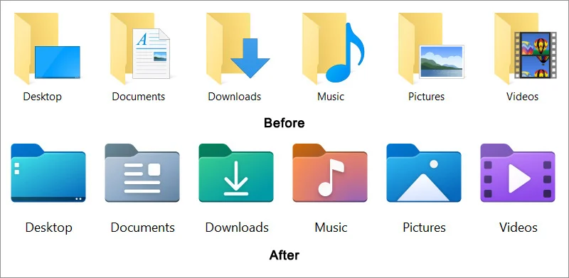

A **shortcut** is a quick way to access a program, file, or folder without having to navigate through multiple steps or directories. It usually appears as a small arrow over an icon. You can place a shortcut anywhere, like on your desktop, to make it easier to open things you use often.

An icon, on the other hand, is a small image or symbol that represents a program, file, or action. When you see an icon, clicking on it will open the program or file directly. So, while an icon can be a shortcut if it links to something else, not every icon is a shortcut. Icons are just visual representations, while shortcuts are specific links that make it easier to access something.

When setting up your **desktop**, you will want to have your most used programs available as **shortcuts**. Programs that come preinstalled on your computer may already have **shortcuts** on your **desktop**. When you install a new program, there is typically a checkbox to automatically create a **shortcut**. However, if a program you have installed already does not have a **shortcut**, you can create one:

1. Locate and left click on your **Start menu.**
2. Search for the program you want to create a shortcut for in your **search bar.**
3. Click “Open File Location.” This may require using the right mouse button to **right click** on the icon and interact with the listed program.
4. **Right click** the program you want to have a **shortcut** for.
5. On the selection menu that pops up, move your cursor over “Send To.”
6. Click on the option **Desktop** (Create **Shortcut**).

Ideally, your **desktop** should only have programs you regularly use to reduce clutter. If your PC came installed with programs you do not intend to use, delete their **shortcuts** by right clicking on them and clicking “Delete”. This will not uninstall them, however.

You can rearrange the shortcuts on your desktop and place them wherever you want. By moving your cursor over to an icon you’d like to move, pressing and holding down the left mouse button, and moving your mouse without letting go, (referred to as “click and drag,”) you can move the shortcut to wherever you’d like it to be. It may be useful to group your icons based on type or what they are used for.

**Start Menu:**

The **Start menu** is, as the name suggests, the main way you can find and “start” **programs** on your computer that do not already have a **shortcut** on the desktop. Depending on your version of Windows, your **Start menu** may look slightly different. This is because Microsoft has rebranded over time, making changes to the logo that they use to identify their products. Updates have also made changes to the menu itself and what **shortcuts** or functions can be accessed through it.

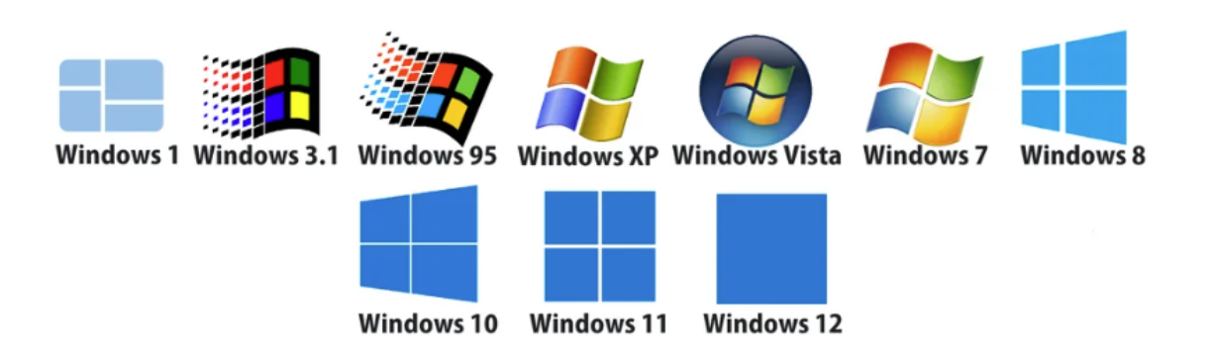

Your Windows version may sort the **programs** on your computer in an alphabetical list, allowing you to “scroll” (using either the scroll bar on the right side of the menu or the scroll wheel in the middle of your mouse) through a full list of all the **programs** you have installed. Alternatively, some versions of Windows might remember what **programs** are used most recently or frequently and provide those at the top of the list. These versions might even require you to click on a button that says “All” to see the complete list of available **programs.**

Another way you can find a **program** is by using the **search bar.** Different versions of Windows have put the **search bar** in different places. Sometimes it is visible to the right of the **start menu**, on your **taskbar**. Other times, you will have to click on the **Start button** to find it. Either way, it should be located relatively low on your screen, and might be indicated with a magnifying glass or the word “search.”

More recent versions of Windows allow you to use the **search bar** to not only search for programs that are installed on your computer, but also to search the internet for new **programs** or for relevant **web pages**. This can sometimes be confusing, because your search can turn up unwanted results. It is important to pay attention to the information around the results. Is your result labeled as “Best Match”? Or is it under a section called “Search the Web”? By paying attention to this context, you can tell if your result is a **program** or **file** that is stored on your computer or if it is a suggested web search.

**Taskbar and System Tray:**



Across the bottom edge of your screen, you should see a bar of **icons** and symbols. This bar or “ribbon” is called your **taskbar.** It is another location for different **shortcuts** to your frequently-used programs, but that’s not all. The taskbar also displays all of the different **programs** that are currently running on your computer. Different versions of Windows might accomplish this in slightly different ways, but there will be some visual difference between a regular **shortcut** and the **icon** of an open **program**. In some cases, open **programs** are outlined with a box and highlighted. Other times, they may simply be indicated by a small line just beneath the **icon**.

Another use of the **taskbar** is to identify which **program** is currently *active,* or what your computer is focusing on at that moment. If you use fullscreen mode for your **programs**, this will indicate which **program** is currently taking up your screen. If you are using windowed mode, however, and can see multiple **programs** at a time, it may only refer to the one that you interacted with most recently. Similarly to open **programs** vs. **shortcuts**, there will be a visual difference between **programs** that are open and running in the background as opposed to your current active **program**. If your open **programs** are normally outlined and appear surrounded by a white box, your active **program** might be a different color, or appear to be pushed in like a button. If open **programs** are indicated by a dot beneath their icon, that dot might get bigger or change color.

At the far right of your **taskbar** is a clock and another set of **icons**. This part of your **taskbar** is called the **system tray.** This is where you can find information about the computer itself, such as the volume, clock, calendar, and internet connection. The volume appears as an **icon** that looks like a megaphone, sometimes including a few radiating lines that indicate the current volume setting. 



Your internet connection **icon** may take a few different forms depending on the type of connection you are using. For example, wireless internet, or WiFi, is represented by a dot with curved lines radiating upward, or sometimes to the side. However, if you are not actively connected to the internet, it may instead look like a globe with a little “no” symbol (a circle crossed through with a diagonal line) symbol to one corner. With a desktop computer, you may also use a wired connection or ethernet. This type of connection is represented by an icon that might look like the wire itself, or like a monitor and a wire together. However they look, you can click on these symbols to adjust your internet settings or connect to a different network.

**Accessibility and Appearance:**

Computer users with impaired vision or mobility might find it difficult to use their device or to read text in a small font. Luckily, most operating systems have provided certain accessibility features and customization options to allow a user to make their experience easier and more pleasant. The downside to this, however, is that accessibility functions are constantly evolving, meaning that each new update might completely change what functions are offered or how to find them.



A good way to locate your device’s accessibility settings is to familiarize yourself with some key terms to use in your **search bar.** “Accessibility” is a good starting point, especially for newer operating systems. This menu might allow you to change things like the size and color of your cursor, making it easier to see. You might also be able to change how fast your cursor moves when you move your mouse, or change the font size of text. Other possible options include color filters, a Narrator or Screen Reader that will read text aloud (text-to-speech), or even live captions that will translate computer audio into readable text that appears on your screen.

Still, even the most recent version of Windows doesn’t keep all of their helpful settings on this menu. You might also search for “Display” or “Display settings” to unlock even more options to customize the way your computer looks. This might include your screen’s brightness, or the ability to make the screen “warmer” or “cooler” by adjusting how much blue light it produces. One other setting that is usually listed under Display is the “Scale” setting. You should be careful adjusting this, because making the computer’s display too large or too small might make it difficult to reach the buttons you need, including the ones you’d need to return your display to a normal size. But a small adjustment might be helpful to make everything on your computer appear just a little bit bigger and easier to see.

The last location we will introduce is the “**Taskbar** Settings” menu. This is where you can adjust your **taskbar’s** appearance and behaviors. You can also adjust what functions are available in your **system tray**. Don’t worry about removing them completely, because even hidden **system tray** functions will be available to you by expanding the menu with the arrow (or “**caret**”) button.

**Managing Program Windows:**

It is important to be aware of what programs your computer is trying to run at any given time. Having many programs open at the same time can not only be confusing and overwhelming for the user, but it can also be draining on your computer. Trying to run too many programs at once might make your computer run more slowly. It can also make it difficult to find the right tool for the job you want to accomplish. Luckily, there are a few different ways to manage your open programs.



You might be familiar with these symbols. They appear at the very top right of a window. To the left is something that looks like a flat line or a minus sign. This is the Minimize function. The next button looks like two squares stacked on top of each other. This is your Maximize button. On the right is a button that looks like an X, called the Close button.

*Minimize:* Using the Minimize button will “collapse” your window, allowing you to view whatever is “underneath” it. This might be another program, or even your desktop. It should be noted that this is not the same as closing the program. You can reopen the window by locating it in your taskbar, where there will be a visual difference between the icons for programs that are running and the icons that just indicate a shortcut.

*Maximize:* This button allows you to enter “windowed mode,” or resize the program window. This might allow you to view multiple programs at the same time, by clicking and dragging the edges of the window to your desired size. While in windowed mode, the Maximize button might look slightly different. Instead of two stacked squares, it might appear as one single square. This indicates that the button can be used to enter fullscreen mode, causing the window to take up the entire screen.

*Close:* This is the button you use when you are finished with a program and would like to turn it off. One thing to know before closing a program is that your progress might not be saved. If a program is closed and reopened, it usually goes back to its “home page,” or starting point. If you have been working on a document, you should save your changes before using the Close button.

**Keyboard Shortcuts:**

In addition to using a mouse, computers are also able to interpret certain commands just by using the keyboard. These are referred to as **keyboard shortcuts.** You may already remember “Ctrl+Alt+Del” from our lesson on how to shut down your computer. This is an example of a **keyboard shortcut**.

To use a **keyboard shortcut**, you must press multiple buttons on your keyboard at the same time. In many cases, you will use a key like “Ctrl” (control) or “Alt”(alternate) in combination with a letter key to tell your computer that you do not want to type the letter, but instead perform a separate function.

If memorizing **keyboard shortcuts** seems overwhelming, don’t worry. All of these functions can be done in other ways, too, usually by using your mouse to click through menus with labeled buttons.

For reference, here is a list of some of the common **keyboard shortcuts.** The “+” only means that the listed keys should be pressed at the same time. You do not need to push the key with the + on it.

1. Ctrl + C: Copy selected text

2. Ctrl + V: Paste copied text

3. Ctrl + Z: Undo last action

4. Ctrl + A: Select all text

5. Ctrl + S: Save document

6. Alt + Tab: Switch between open applications

7. Ctrl + F: Find text in a document

8. Ctrl + P: Print document

9. Ctrl + X: Cut selected text

10. Shift + Arrow keys: Select text character by character or line by line.

**Managing Your Files**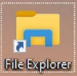

**File Explorer:**

On PC, you can enter the File Explorer by either clicking the File Explorer shortcut or pressing the Windows Key + E on your keyboard. File Explorer is a helpful tool that lets you browse and manage the files and folders on your computer, much like a digital filing cabinet. It makes it simple to find, open, organize, and remove documents, pictures, music, and other files.

Your computer comes with a set of premade folders, ready for you to use. This will include default file locations to save Pictures, Videos, Documents, Downloads, and your Desktop. When you download a file from the internet, it will automatically go to your Downloads folder. You can move this file by using the Cut and Paste features to put it somewhere that may be easier for you to find. You can use the Cut and Paste feature by **right clicking** on the file you want to move and selecting Cut, then **right clicking** where you want the file to go and selecting Paste. You can also use the shortcut Ctrl+X to Cut with the file you want to move highlighted and use Ctrl+V to Paste in the folder you want to put the file into.

Something you might want to keep in mind is that you can save a file directly to your desktop by placing it into the Desktop folder. This will create an **icon** that leads to your file on the desktop screen, allowing you to find it quickly and easily. However, overusing this feature can create visual clutter on your desktop and make it harder to identify the exact file you’re looking for. You might want to organize your files into more specific folders, allowing for further organization. For example, if you need to save scanned copies of your receipts for work expenses and want to have quick access to all of these files at once. To create a new folder follow these steps:

**Method 1: File Explorer**

1. Open File Explorer from your taskbar.
2. Navigate to the Desktop folder, visible in the left column. This may require scrolling through a list of options to find the correct one. Click on the word Desktop to open the folder.
3. In the list of options toward the top of your File Explorer, click on the button labeled New Folder.
4. Rename the folder to clarify what files are inside.

**Method 2: From the Desktop**

1. Minimize any programs you may have open. You should start by looking at your desktop.
2. Use your mouse to right click anywhere on your desktop. You want to find a blank space that does not have any icons in it yet, as you will be making a new icon.
3. A new menu should appear next to your cursor with several possible actions. Use your cursor to hover over the word “New.” Another menu will appear beside this button. Be careful to keep your cursor over the word “New” as you move it into the new menu, following the button from side to side. If your cursor moves over a different option, the menu will disappear. From the new options, click “Folder.”

The folder you have created will be automatically named “New Folder,” but this text will appear highlighted in blue, indicating that it is selected. This means that you can begin typing a new name for the folder without needing to use the mouse or your Backspace key. Any new text you type will automatically replace the highlighted words. Pick a name that will remind you of what you want to keep in this folder, such as “Receipts.” If you click somewhere else, the selection will disappear, but don’t worry. You can still rename your file at any time by **right clicking** on it and selecting “Rename.”

The File Explorer method will work anywhere in your File Explorer **program**. You can use this tool to create as many folders as you like to keep track of your files, and even make folders inside of folders inside of folders. You will want to make a clear folder system on your computer that groups files by projects, topics, or types of work. Create specific subfolders for different categories. Give your files descriptive names so you can find them easily, and regularly delete any files you don't need. Utilize tags or search tools for quicker access. An organized setup saves time, reduces stress, boosts productivity, and simplifies file management and backup.

**Installing Apps and Programs**

PC users can find new software in several places, like websites that specialize in software downloads, online stores like the Microsoft Store, or platforms like Steam for gaming. To install the software, you can usually download it from the website or store, then open the downloaded file and follow the instructions on the screen to complete the installation.

Sometimes, you might need to adjust settings or restart your computer afterward. Often, programs might have a tool to install the program called a Setup Wizard. This simplifies the process of installation, but there are also things that you might need to look out for when it comes to the Setup Wizard process. Sometimes during installation, there will be the option to install something else from the same software provider. You may need to read carefully and uncheck boxes to avoid installing software you may not use.

**Relevant Terms:**

**Application/App:** An application is a software program for computers or mobile devices, such as email, web browsers, and games, each serving a specific purpose.

**Check/Uncheck:** Using your mouse to click on a “checkbox” in a menu. Checking a box activates an option, while unchecking it deactivates it. These boxes allow quick selection of settings, such as agreeing to terms or subscribing to newsletters, and customize subsequent actions like email preferences.

**Download:** To transfer a file from one device to another over the Internet, like from your computer or phone. You can think of it as bringing something down to your device from the Internet.

**Driver:** A program that enables your computer to communicate with hardware devices, like printers and graphics cards. Each device requires its own driver to function properly. Without them, devices may malfunction.

**Install:** the process of setting up a new program after downloading it. This process is not required for single files like text documents or images.

**Installation/Setup Wizard:** The Setup/Install Wizard is a program that is often included when you download a piece of software. It simplifies the installation process and hardware setup by guiding users step by step. It ensures proper configuration, prevents installation errors, and makes the process user-friendly, especially for those less tech-savvy. Usually, the Wizard will open automatically when you start the new program for the first time.

**Malware:** Malicious software. This refers to harmful programs or codes like trojans, worms, spyware, and adware. These are created to damage your computer or gather your personal information.

**Microsoft Store:** A pre-installed online platform to purchase and download software, games, and apps for Windows devices, offering a safe and convenient way to buy and update your content.

**Software:** A program, or set of instructions, that runs on a computer.

**Subscription:** An agreement with a service provider that involves paying a recurring fee, usually once a month or once a year, to access products or services.

**System Admin/Administrator:** A user who manages computer systems and networks, ensuring smooth operations by installing software, troubleshooting, maintaining security, backing up data, and performing updates. Usually, at least one user profile on your device is assigned the Administrator, allowing that user to make changes to the way the computer works. The login for that profile may be required to allow a different user to download or install software.

**Terms and Conditions:** The legal rules that users must agree to in order to use a product or service. This might include details about who can use it and how, or warranty information.

**Virus:** Also called self-replicating software, a virus is a type of computer glitch that can spread by attaching itself to emails, making copies of itself and using up your computer's memory. A trojan is different; it acts like a sneaky trick, letting uninvited people get into your computer so they can send out harmful emails or spam.

**Installing a Program Using the Microsoft Store**

Modern versions of Windows come with a pre-installed program called the Microsoft Store. It functions similarly to an app store like you might use on a smartphone, allowing you to search through many programs at once. You can read through reviews and look at images of the program before ever downloading it to see if it is something you want to use.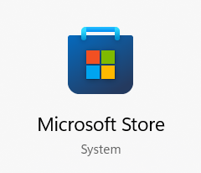

1. **Open the Microsoft Store:** You can use the Search Bar on your taskbar or under your Start menu to find the Microsoft Store. The icon will look like a shopping bag with the Windows Logo in the center. Click on the program to open it.
2. **Find the program:** The Microsoft Store gives you the ability to search for a program by its name or by what it does. You can even search for games, movies, or TV shows.
3. **Read about the program:** The Microsoft Store shows you information about the program itself, like reviews or descriptions of what it can do. Some programs might have a cost. It might even require a payment for every month or every year you use the program. This type of payment is called a subscription. If you stop paying your subscription fees, you will lose access to these programs. You should look through the website to make sure that the program sounds right for your needs.
4. **Click “Get”:** Once you have chosen a program, click the “Get” button to start the download process.
5. **Wait:** The Microsoft Store will download and automatically install the program for you. This saves the program to your computer.
6. **Open the Program:** The “Get” button will now say “Open” instead. Once the program is open, you might see a checkbox with a few new options, like “Allow this app to: Pin to taskbar, Pin to Start, Create Desktop shortcut, Auto-start on device login.” You can check or uncheck whichever options you like. Even without checking any of these options, you will still be able to locate your new app in your Start Menu.

**Installing a Program Using an Internet Browser**

Some programs might not be available through the Microsoft Store. For these, you should browse the internet to find the website where the program is available.



1. **Click on your internet browser:** Internet browsers let you use the internet. The most common Internet browsers are Google Chrome, Mozilla Firefox, Opera, Safari, or Microsoft Edge (formerly Internet Explorer). Microsoft Edge is pre-installed on modern versions of Windows. Its icon looks like a blue and green wave, shaped vaguely like an “e.”
2. **Find the program:** In the search bar at the top, type the name of the program you want. When setting up a new computer, it is good to start by installing anti-malware software to help keep your computer safe from viruses. Programs like Malwarebytes and CCleaner are great for keeping your PC protected. Smart Defrag is also good for keeping clutter from slowing down your PC.
3. **Read about the program:** The website hosting the program will likely contain information about the program itself, like reviews or descriptions of what it can do. Some programs might have a cost. It might even require a payment for every month or every year you use the program. This type of payment is called a subscription. If you stop paying your subscription fees, you will lose access to these programs. You should look through the website and make sure that the program sounds right for your needs.
4. **Look for the Download button:** When you see the program you want, find the button that says "Download." Click on it. Be careful to make sure what you are clicking on is not an ad as some websites have ads disguised as download buttons.
   1. *Tip!* Some programs have specific versions that match your Operating System. There might be a different button to download the Windows version and the Mac version of a program. Be careful to download the version that will work well with your device.
5. **Wait for it to finish:** Look at the screen and wait. Usually, a text box will pop up with the estimated time for the file to download.
6. **Find the download:** When it's done, look for the download icon and click it. It usually looks like a downward-pointing arrow with a tray underneath. This will bring up a list of recent downloads. You can either click the folder icon next to the file or right click and select “Show File Location” to quickly find the download. Downloads typically default to your “Downloads” folder.
7. **Open the download:** Click on the file that you have downloaded to install it. It usually has the name of the program.
8. **Follow the instructions:** A new window will appear. This is called an Installation or Setup Wizard. It makes installing programs quicker and easier. Read through the text on the screen and click “Next” or “Install” to move to the next screen. Some Installation Wizards may try to install another program along with the one you want. You should carefully read through the text to make sure your program is set up the way you want it to be. Uncheck any boxes for installing unwanted programs and hit next to continue.
   1. The Installation Wizard might ask you to agree to certain Terms and Conditions to use the program.
9. **Wait again:** It might take a few minutes to install.
10. **Finish up:** When it says “Done” or “Finish,” you can close the window.
11. **Find the program:** Search for the program in the search bar. Click on it to open and use it.

**Uninstall a Program:**

1. Find the program:
2. Right click the program:
3. Select “Uninstall”

**OR:**

1. Type “Add or Remove Programs” into the Search Bar and click on that setting in the search.
2. Search within the list of Apps and Features until you find the program you want to uninstall. Click that program.
3. Click “Uninstall”.

**Useful Programs to Install**

Apps and programs allow a computer to offer more in terms of what a user can do. You may want to install more programs onto a new computer. Here is a short list of types of programs you could start with.

**Antimalware Software** - This helps keep your computer safe from malware (computer programs designed to hurt your computer or steal personal information), like viruses. Malwarebytes and CCleaner are good programs for keeping your computer safe.

**Web Browser** - This helps you look at websites and find information online, like Google Chrome or Mozilla Firefox. Many computers come with Microsoft Edge or Internet Explorer as the default web browser, but both have security issues. Internet Explorer is outdated and unsafe, while Microsoft Edge raises privacy concerns by collecting user data. Consider these risks before using either browser.

**Word Processor** - Word Processors, like Microsoft Word or Google Docs, let you write stories, school papers, or notes. They are often used in professional settings as well.

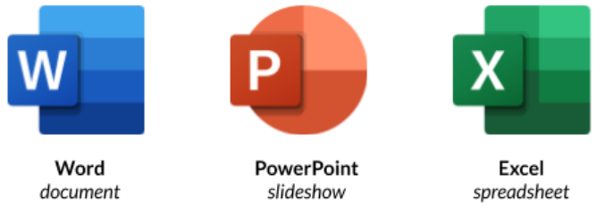

**Spreadsheet Programs** - Spreadsheet programs, like Microsoft Excel or Google Sheets, have gridded pages and math functions that can make tracking monthly expenses or planning events easier to manage.

**Slideshow Programs** - Slideshow Programs, like Microsoft PowerPoint or Google Slides, can help present ideas with accompanying images. They can also be used to make slideshows of photos for an event, like commemorating a wedding.

**Email Management Program** - Email Management Programs can help you keep tabs on recent emails and often have a built-in calendar. Common programs like this are Gmail or Outlook.

**Media Player** - Media Players let you play music and watch videos, like VLC or Windows Media Player. Your PC may come with these pre-installed.

**Photo Editor** - Photo editing programs allow you to edit images. For basic edits, use tools like Paint. For advanced features, Adobe Photoshop is the most professional option at $9.99/month. Free alternatives include GIMP, Krita, and Canva.

**Games** - Games are fun programs you can play when you're bored. Steam or the Microsoft Store are safe platforms for buying and installing games.